**Practical – 1 :**

create table salesman (salesman_id int PRIMARY KEY,

name varchar(20),city varchar(30), commission decimal(5,2)

);

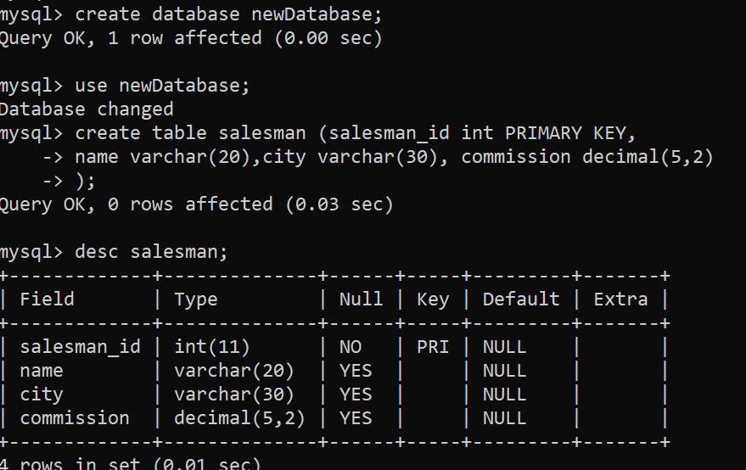

create table customer (

customer_id int PRIMARY KEY,

customer_name varchar(50),city varchar(20), salesman_id int

, FOREIGN KEY (salesman_id) REFERENCES salesman(salesman_id)

);

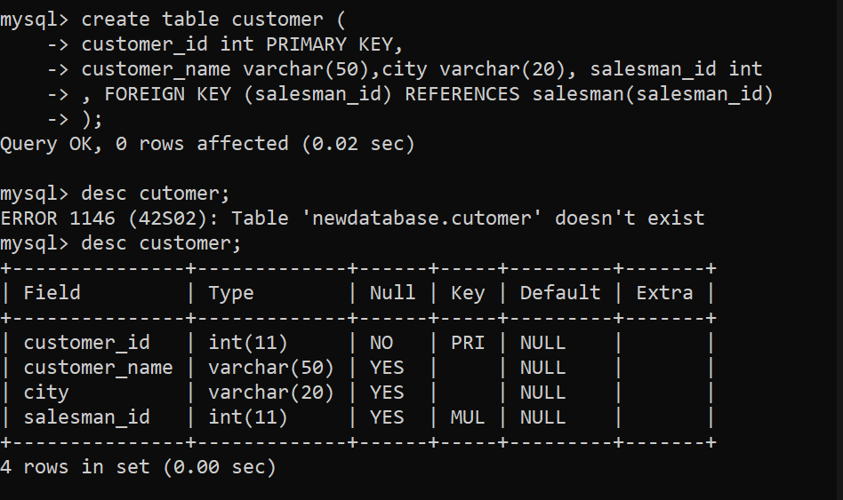

create table orders (

order_no int, purch_amt decimal(10,2),order_date DATE,

customer_id int, salesman_id int,

FOREIGN KEY (customer_id) REFERENCES customer(customer_id),

FOREIGN KEY (salesman_id) REFERENCES salesman(salesman_id)

);

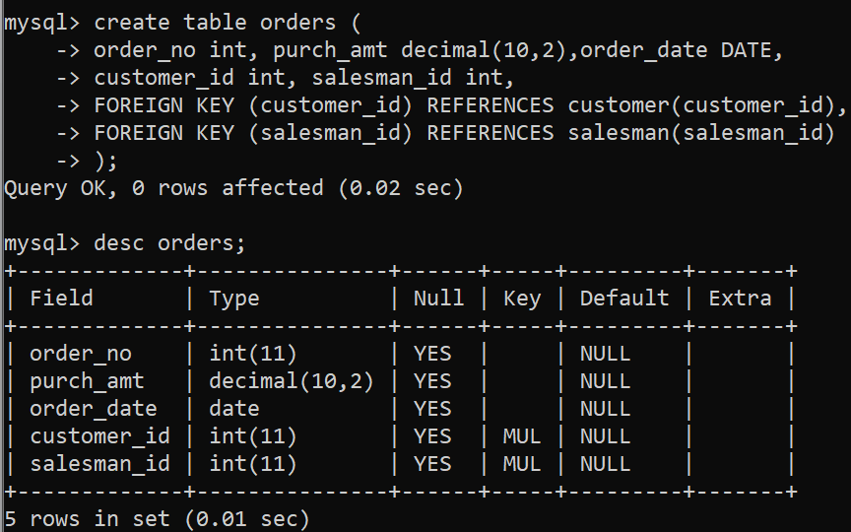

-- Insert data into the salesman table  
INSERT INTO salesman (salesman_id, name, city, commission) VALUES  
(5001, 'James Roop', 'New York', 0.15),  
(5002, 'Nail Knite', 'Paris', 0.13),  
(5005, 'Pit Alan', 'London', 0.11),  
(5006, 'Mc Lyon', 'Paris', 0.14),  
(5003, 'Larson Hen', 'Rome', 0.12),  
(5007, 'Paul Adam', 'Rome', 0.13);

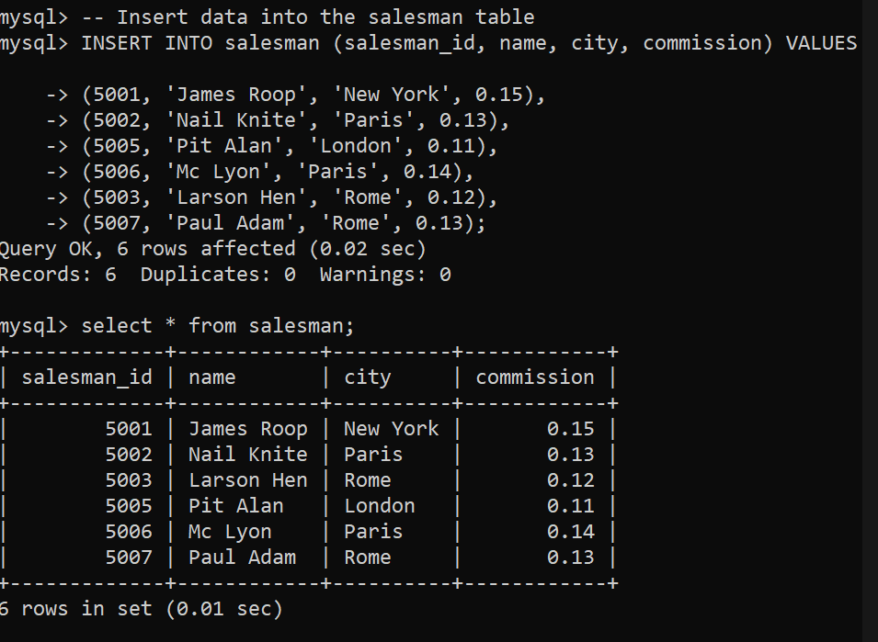  
  
-- Insert data into the customer table  
INSERT INTO customer (customer_id, customer_name, city, grade, salesman_id) VALUES  
(3002, 'Nick Rimando', 'New York', 100, 5001),  
(3007, 'Graham Zusi', 'California', 200, 5002),  
(3005, 'Brad Guzan', 'London', 200, 5005),  
(3008, 'Fabian John', 'Paris', 300, 5006),  
(3004, 'Raul Davis', 'New York', 200, 5001),  
(3003, 'Geoff Castro', 'Berlin', 100, 5002),  
(3009, 'Julian Green', 'London', 300, 5005),  
(3001, 'Joey Allidor', 'Moscow', 200, 5007);

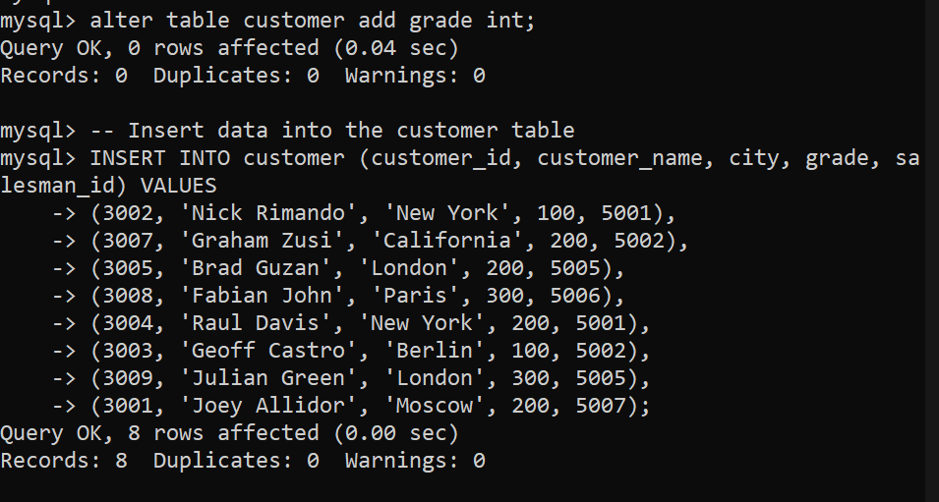

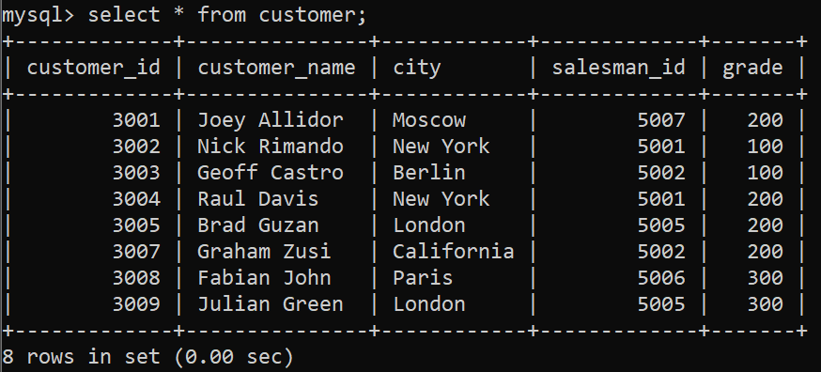

-- Insert data into the orders table  
INSERT INTO orders (order_no, purch_amt, order_date, customer_id, salesman_id) VALUES  
(70001, 150.5, '2016-10-05', 3005, 5002),  
(70009, 270.65, '2016-10-05', 3001, 5005),  
(70002, 65.26, '2016-10-05', 3002, 5001),  
(70004, 110.5, '2016-08-17', 3009, 5003),  
(70007, 948.5, '2016-09-10', 3005, 5002),  
(70005, 2400.6, '2016-07-27', 3001, 5007),  
(70008, 5760.0, '2016-09-10', 3003, 5002),  
(70010, 2480.4, '2016-10-20', 3007, 5002),  
(70003, 250.45, '2016-10-10', 3008, 5006),  
(70011, 75.29, '2016-10-06', 3003, 5007);

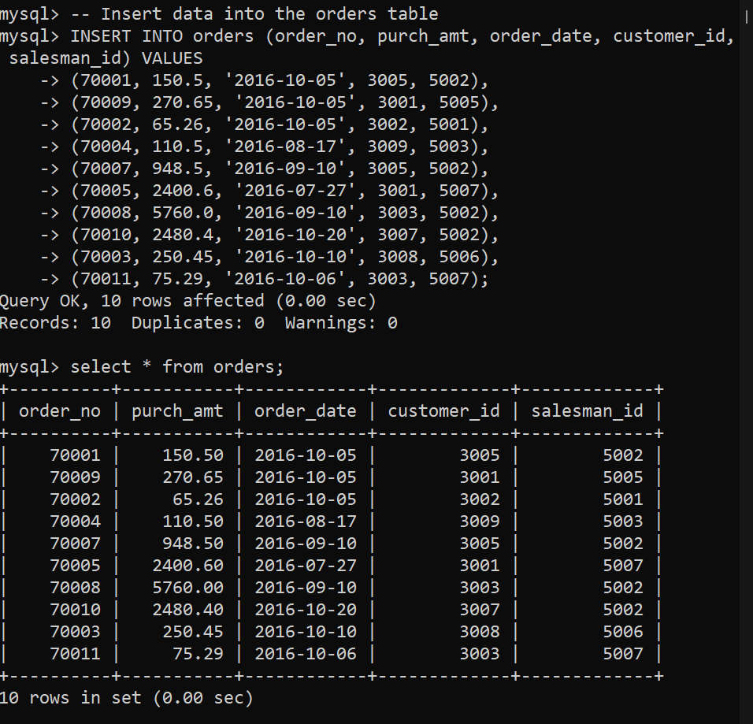

1. Display name and commission for all the salesmen.

select name, commission from salesman;

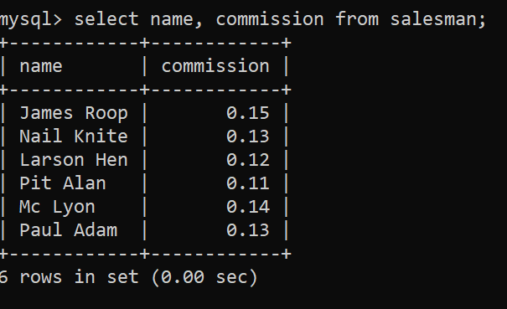

1. Retrieve salesman id of all salesmen from orders table without any repeats.

select distinct salesman_id from orders;

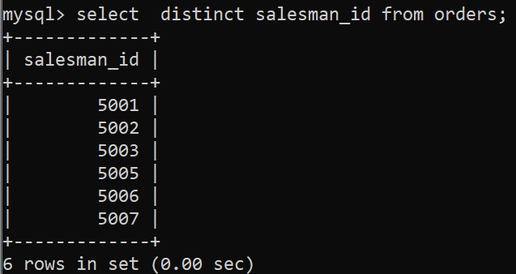

1. Display names and city of salesman, who belongs to the city of Paris.

select name,city from salesman where city='Paris';

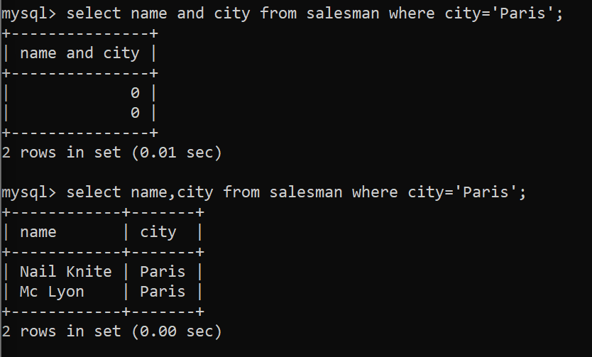

1. Display all the information for those customers with a grade of 200.

select*from customer where grade=200 ;

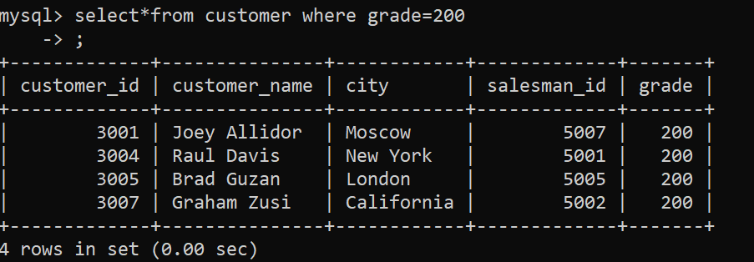

1. Display the order number, order date and the purchase amount for order(s) which will be delivered by the salesman with ID 5001

select order_no,order_date,purch_amt from orders where salesman_id=5001;

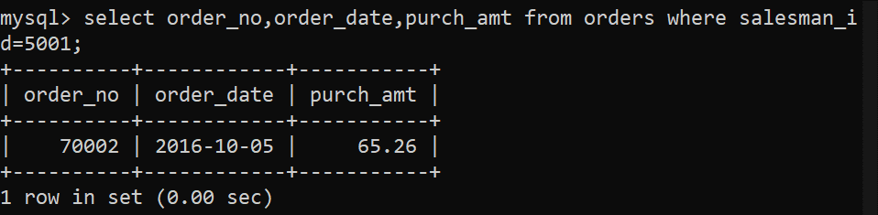

1. Display all the customers, who are either belongs to the city New York or not had a grade above 100.

select*from customer where city='New York' or grade>100;

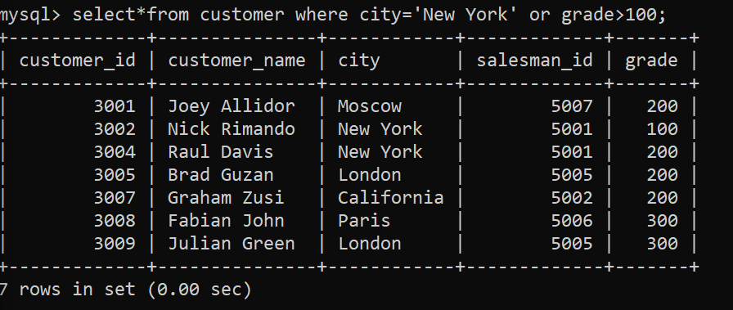

1. Find those salesmen with all information who gets the commission within a range of 0.12 and 0.14.

select * from salesman where commission between 0.12 and 0.14;

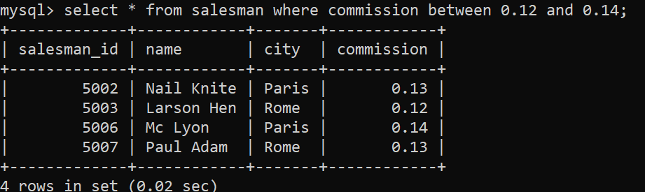

1. Find all those customers with all information whose names are ending with the letter 'n'.

select * from customer where customer_name like '%n';

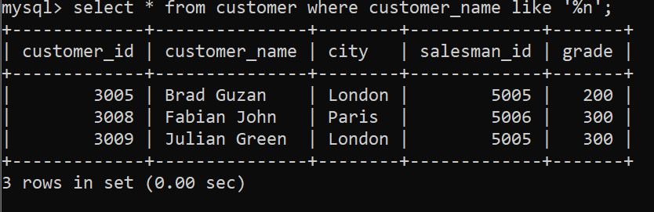

1. Find those salesmen with all information whose name containing the 1st character is 'N' and the 4th character is 'l' and rests may be any character.

select*from salesman where name like 'n__l%';

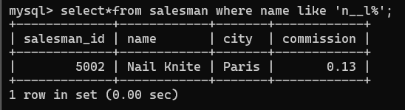

1. Find that customer with all information who does not get any grade except NULL.

select*from customer where grade is NULL;



1. Find the total purchase amount of all orders.

select sum(purch_amt) from orders;

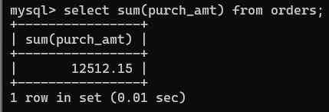

1. Find the number of salesman currently listing for all of their customers.

select count(distinct salesman_id) from salesman;

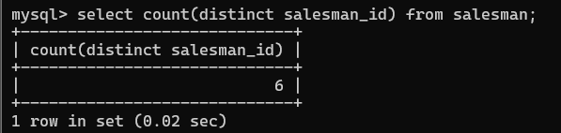

1. Find the highest grade for each of the cities of the customers.

select city,max(grade) from customer group by city;

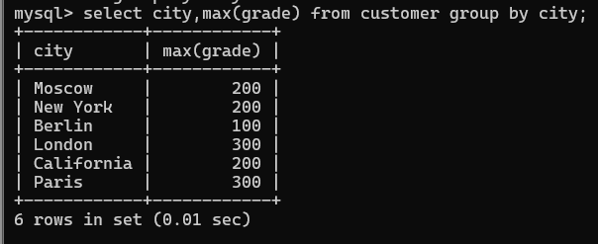

1. Find the highest purchase amount ordered by each customer with their ID and highest purchase amount.

select customer_id,max(purch_amt) from orders group by customer_id;

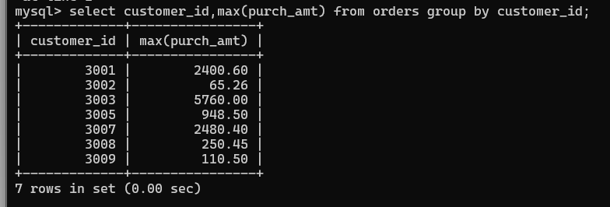

1. Find the highest purchase amount ordered by each customer on a particular date with their ID, order date and highest purchase amount.

select customer_id,order_date,max(purch_amt) from orders group by customer_id,order_

date;

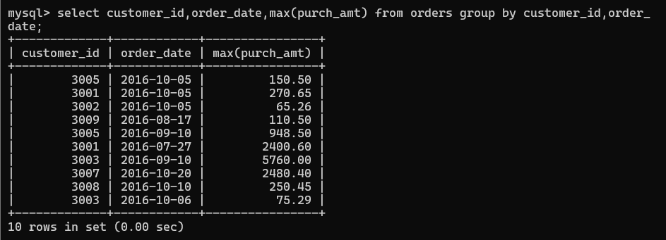

1. Find the highest purchase amount on a date '2012-08-17' for each salesman with their ID.

select salesman_id,max(purch_amt) from orders where order_date='2012-08-17' group by salesman_id;

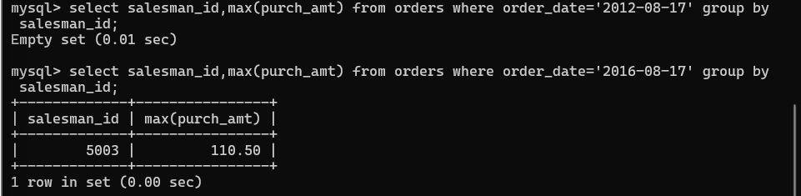

1. Find the highest purchase amount with their customer ID and order date, for only those customers who have the highest purchase amount in a day is more than 2000.

select customer_id,order_date,max(purch_amt) from orders

-> group by customer_id,order_date

-> having max(purch_amt)>2000;

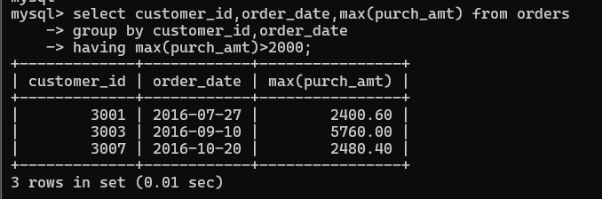

1. Write a SQL statement that counts all orders for a date August 17th, 2012.

select count(*) from orders where order_date='2012-08-17';

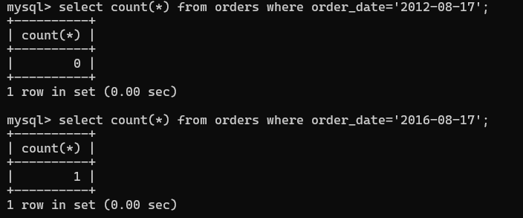

1. Count the customers with grades above Lonodon’s average.

SELECT COUNT(*) FROM customer

WHERE grade > (

SELECT AVG(grade)

FROM customer

WHERE city = 'London' );

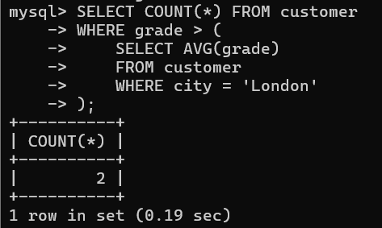

1. Find the name and numbers of all salesmen who had more than one customer.

(USING SUBQUERY)

SELECT name, salesman_id

FROM salesman

WHERE salesman_id IN (

SELECT salesman_id

FROM customer

GROUP BY salesman_id

HAVING COUNT(customer_id) > 1 );

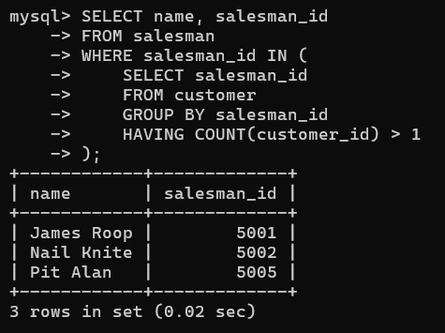

(USING JOINS)

SELECT s.name , s.salesman_id, COUNT(c.customer_id) FROM salesman s

JOIN customer c ON s.salesman_id = c.salesman_id

GROUP BY s.salesman_id, s.name

HAVING COUNT(c.customer_id) > 1;

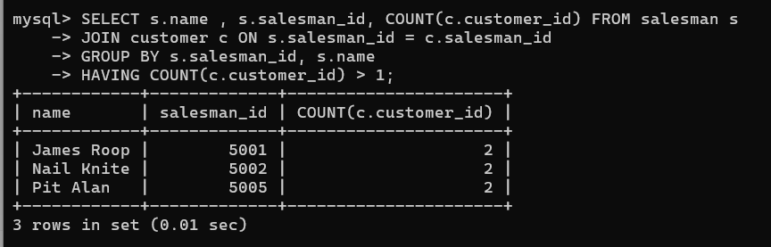

1. List all salesmen and indicate those who have and don’t have customers in their cities (Use UNION operation.)

-- Salesmen who have customers in their cities

SELECT s.name, s.salesman_id, s.city, 'Has Customers' AS status

FROM salesman s

JOIN customer c ON s.city = c.city

UNION

-- Salesmen who don't have customers in their cities

SELECT s.name, s.salesman_id, s.city, 'No Customers' AS status

FROM salesman s

WHERE s.city NOT IN (

SELECT DISTINCT city

FROM customer );

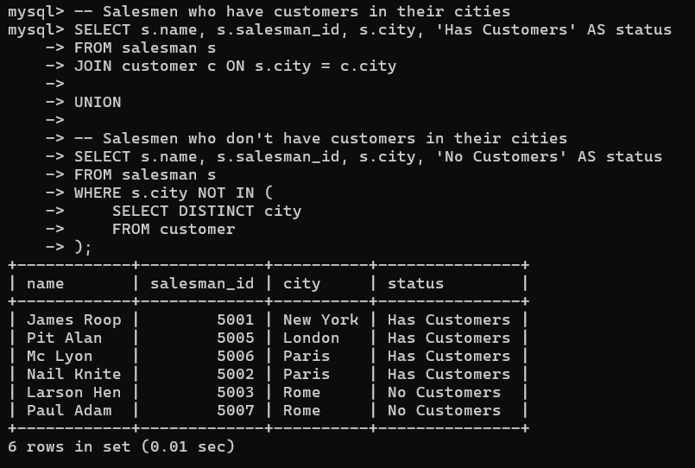

1. Create a view that finds the salesman who has the customer with the highest order of a

day.

CREATE VIEW highest_order_salesman AS

SELECT

o.order_date,

o.purch_amt ,

o.customer_id,

c.customer_name,

o.salesman_id,

s.name

FROM orders o

JOIN customer c ON o.customer_id = c.customer_id

JOIN salesman s ON o.salesman_id = s.salesman_id

WHERE (o.order_date, o.purch_amt) IN (

SELECT order_date, MAX(purch_amt)

FROM orders

GROUP BY order_date );

select * from highest_order_salesman ;

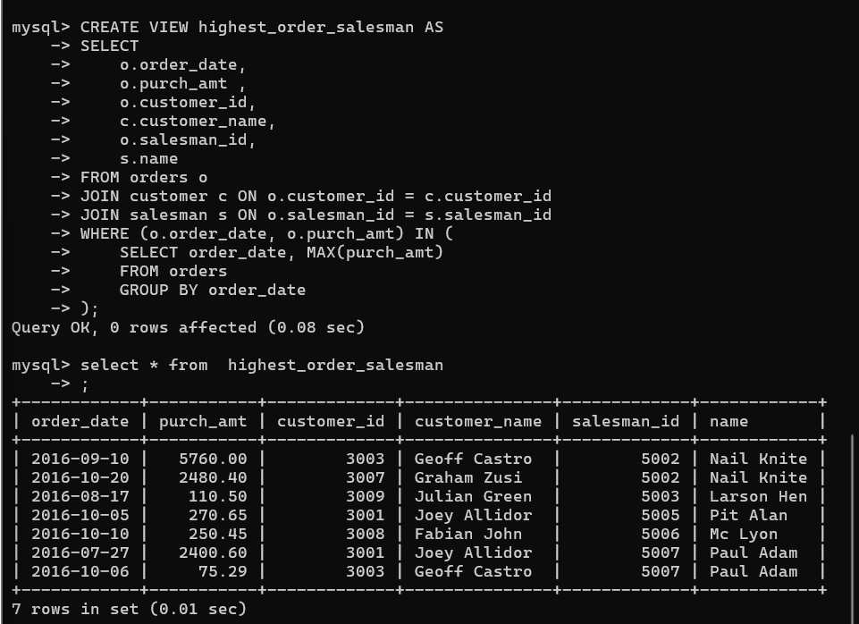

1. Demonstrate the DELETE operation by removing salesman with id 5001. All his orders

must also be deleted

DELETE FROM orders WHERE salesman_id = ( SELECT salesman_id FROM salesman WHERE salesman_id = 5001 );

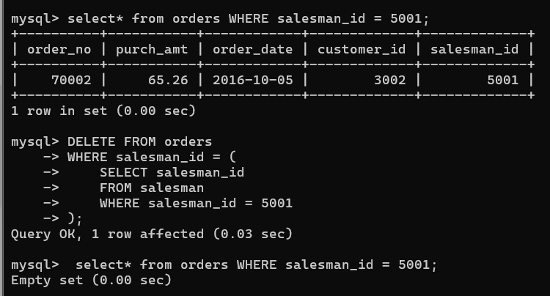

**Practical – 2 :**

Creating Database “Movies”

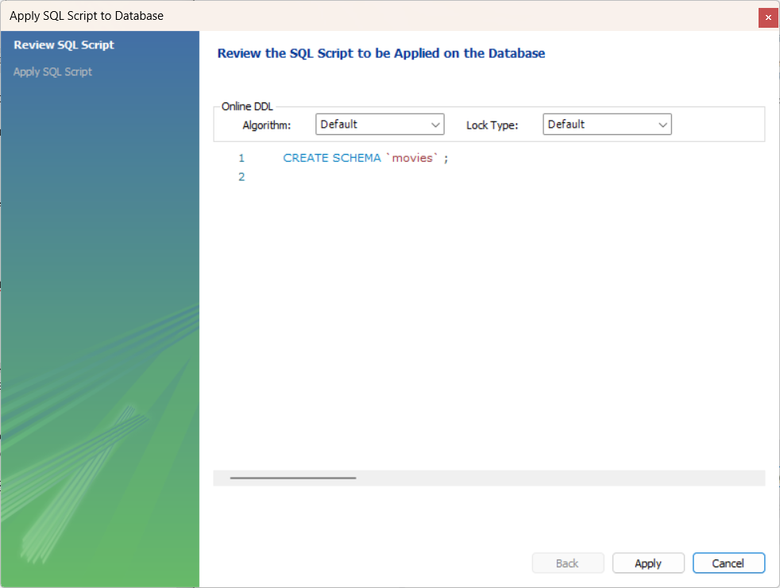

Creating table “Actor”

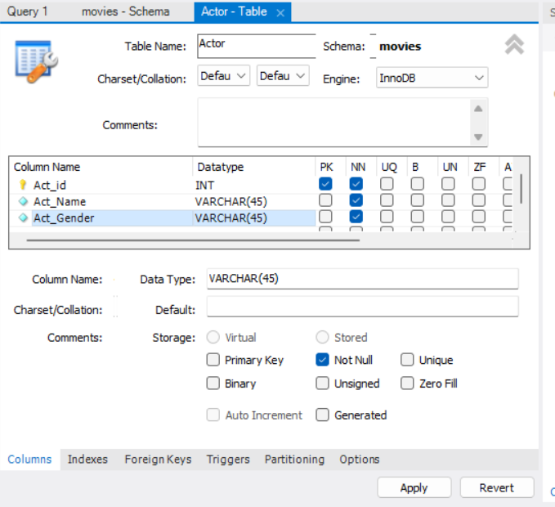

Executing the command

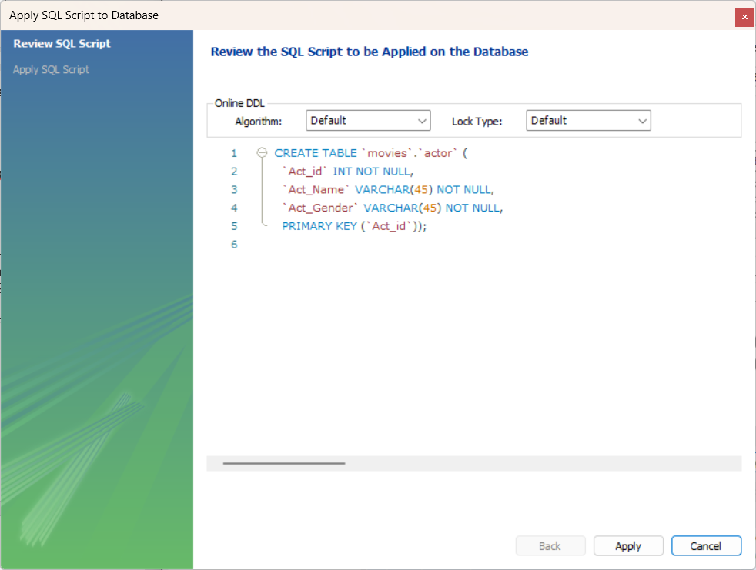

Creating table “Movie”

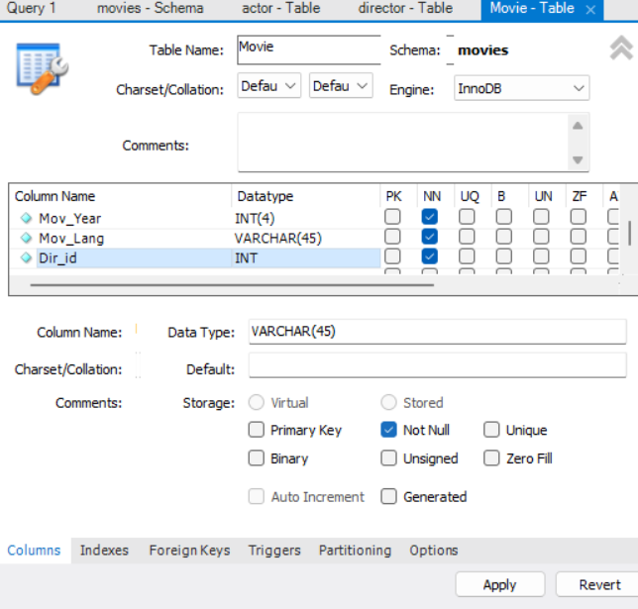

Adding a foreign key

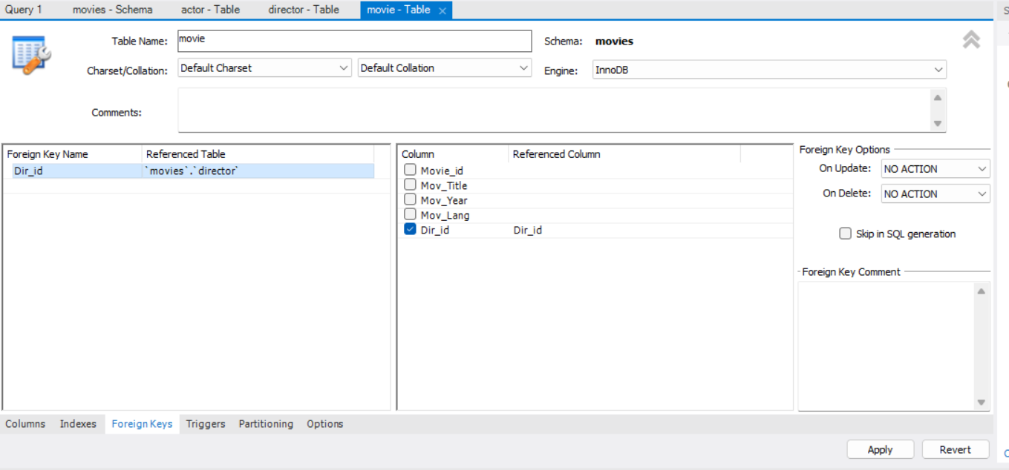

Executing the command

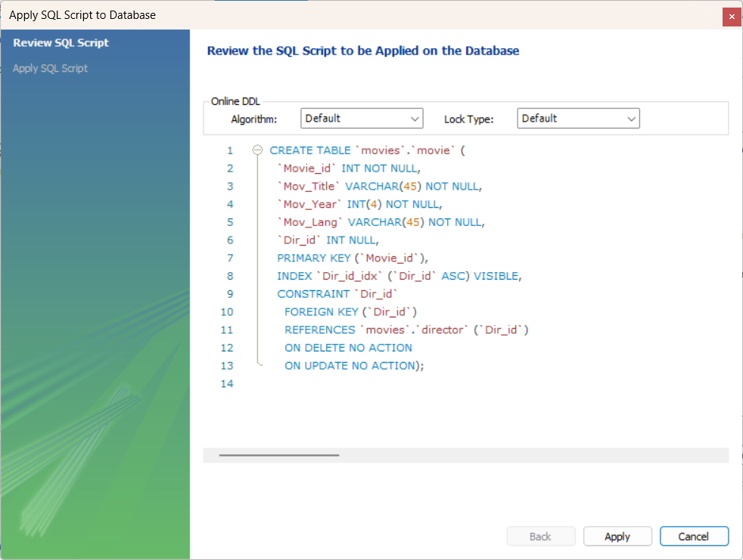

Creating table “Movie_Cast”

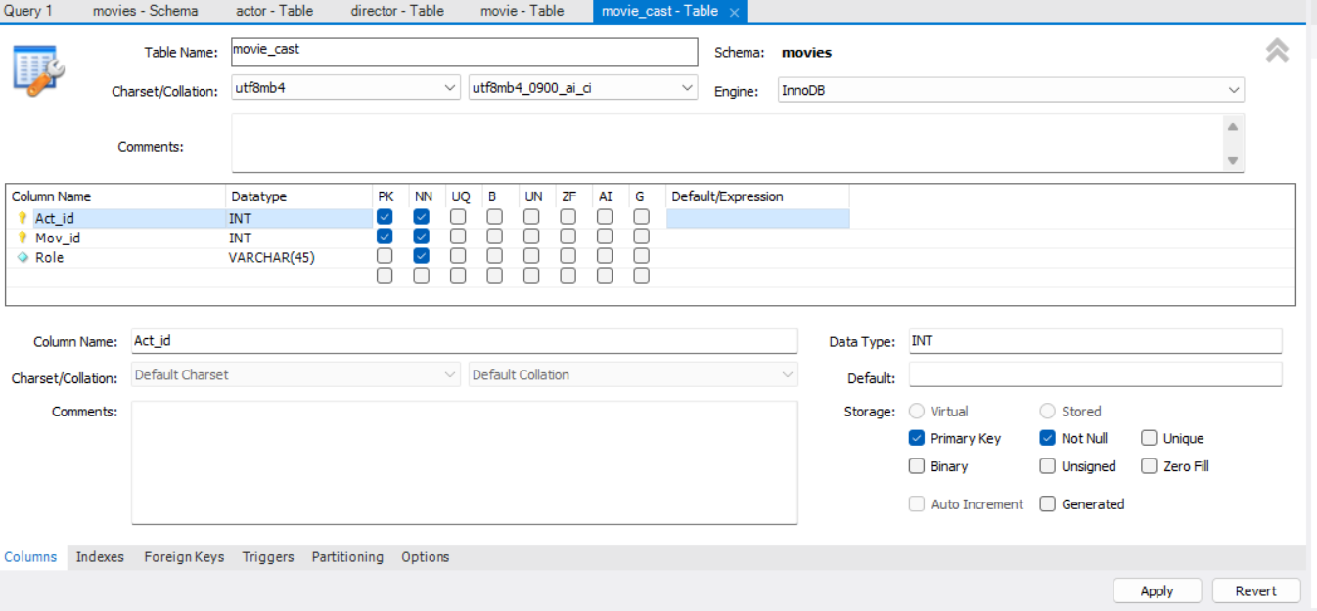

Adding a foreign key

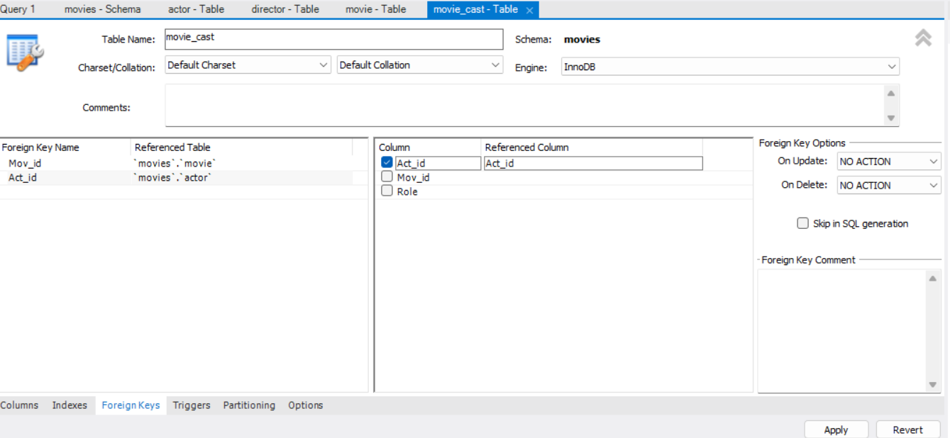

Executing the command

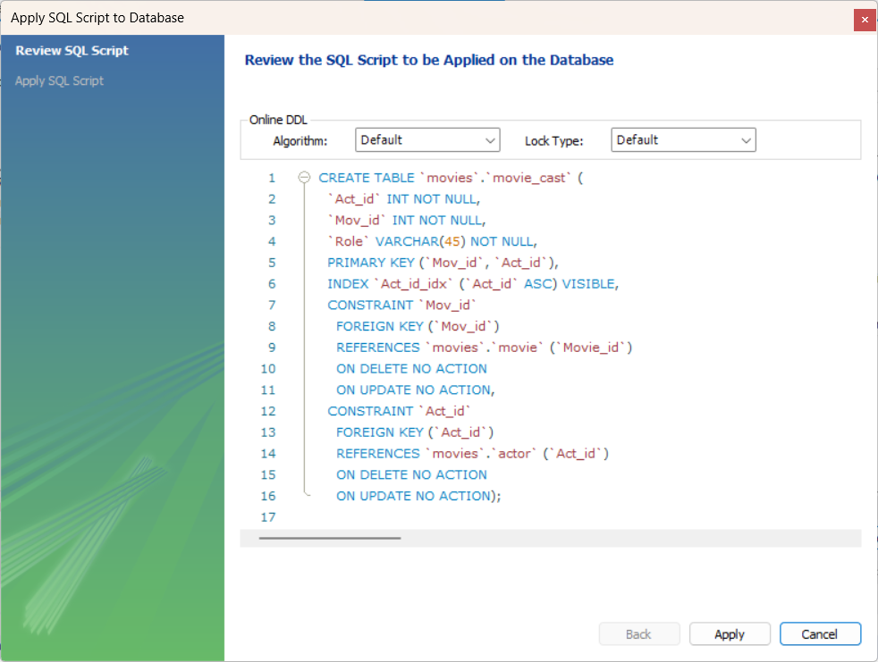

Creating table “Ratings”

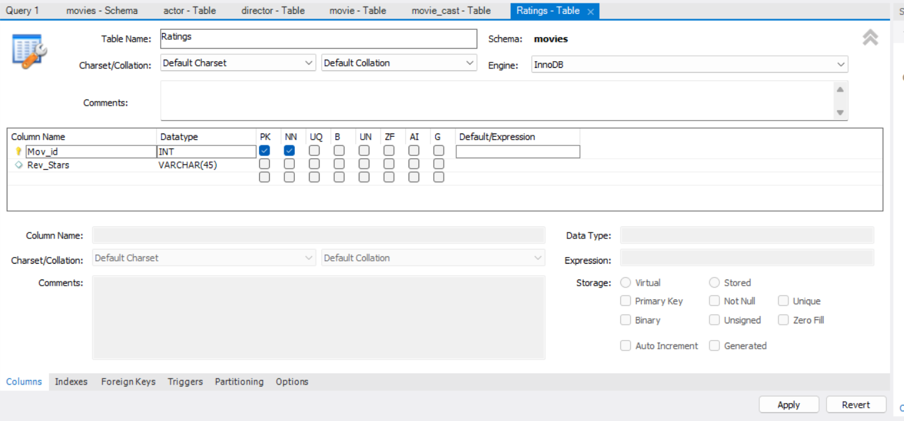

Adding a foreign key

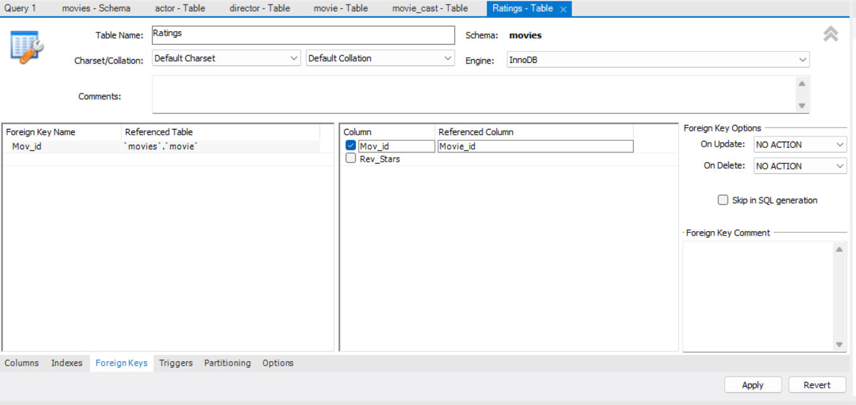

Executing the command

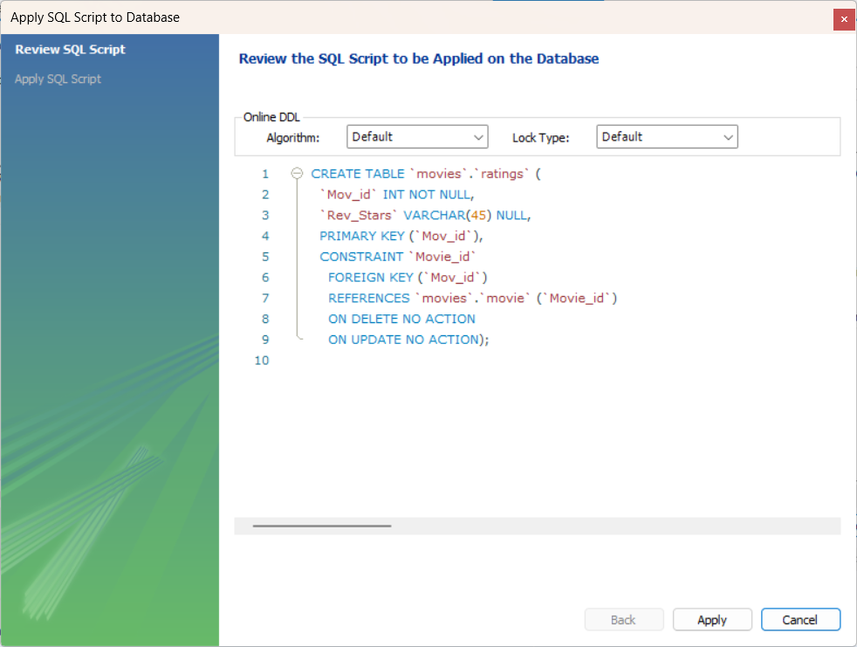

Inserting data into “Actor”

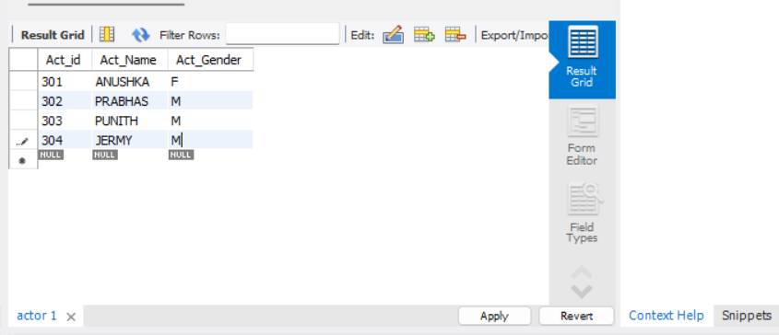

Executing the command

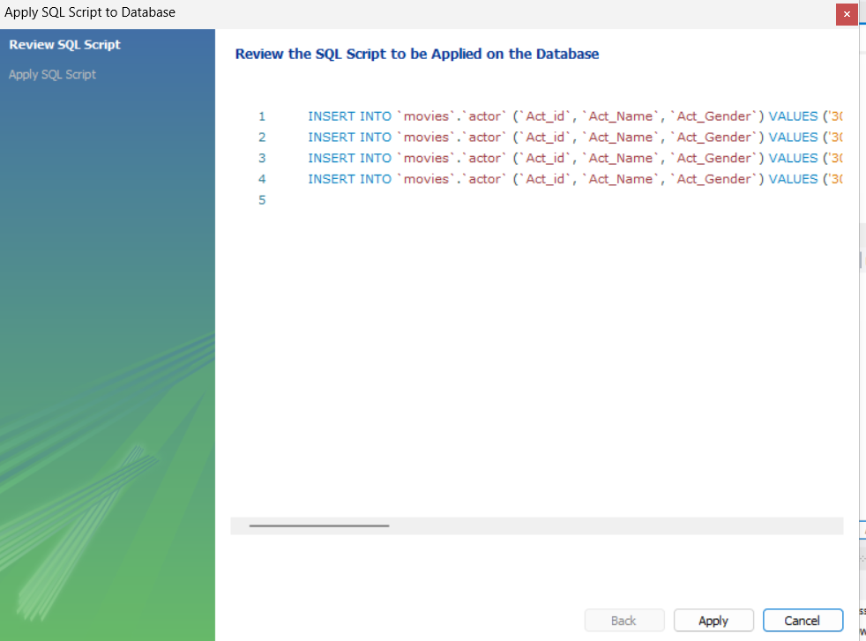

Inserting data into “Director”

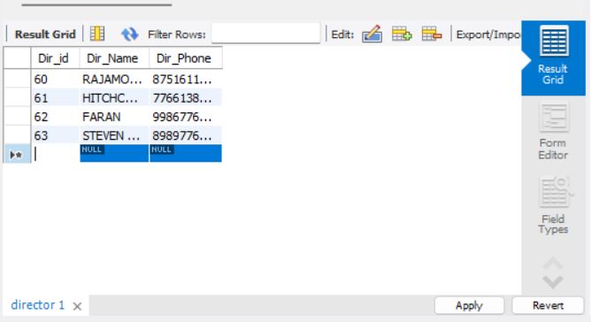

Executing the command

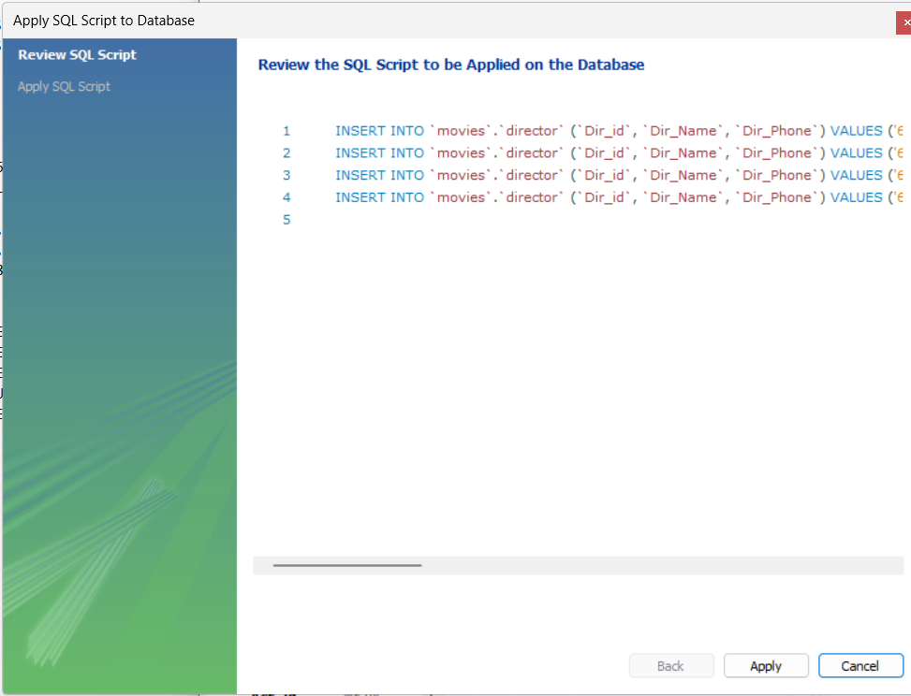

Inserting data into “Movie”

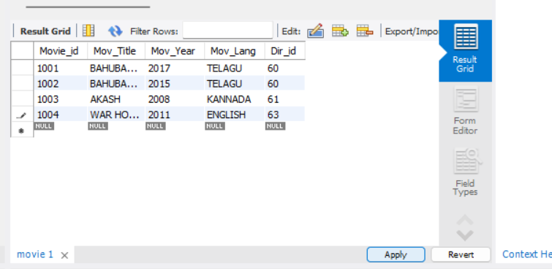

Executing the command

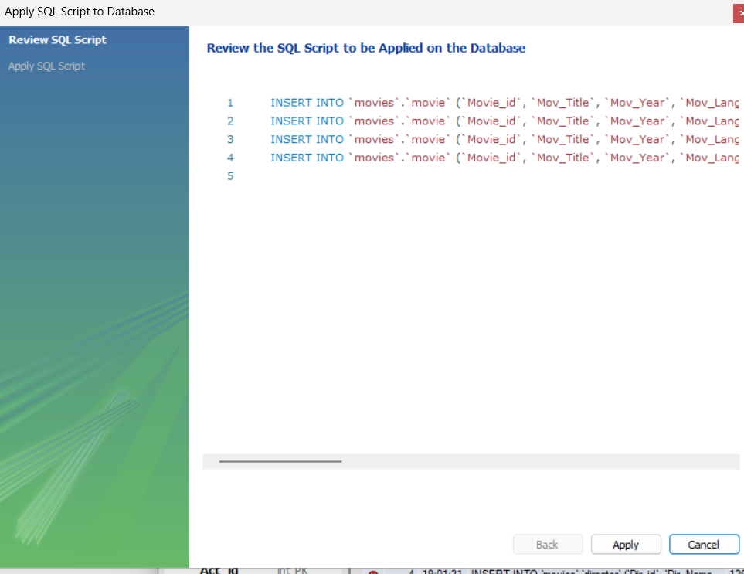

Inserting data into “Movie_Cast”

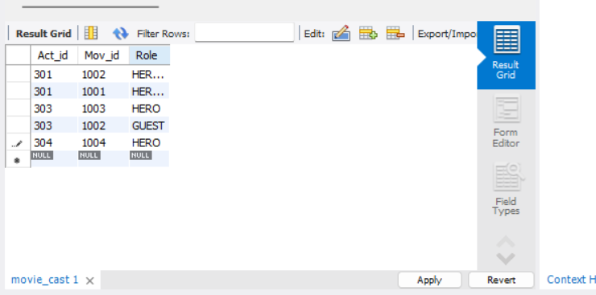

Executing the command

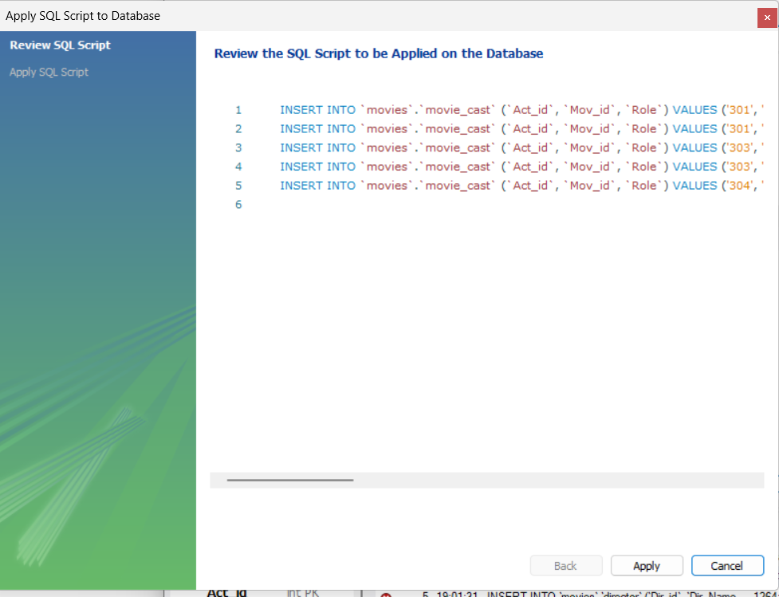

Inserting data into “Ratings”

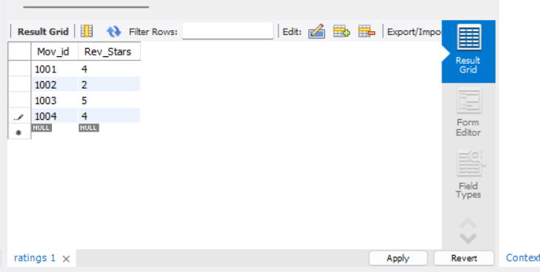

Executing the command

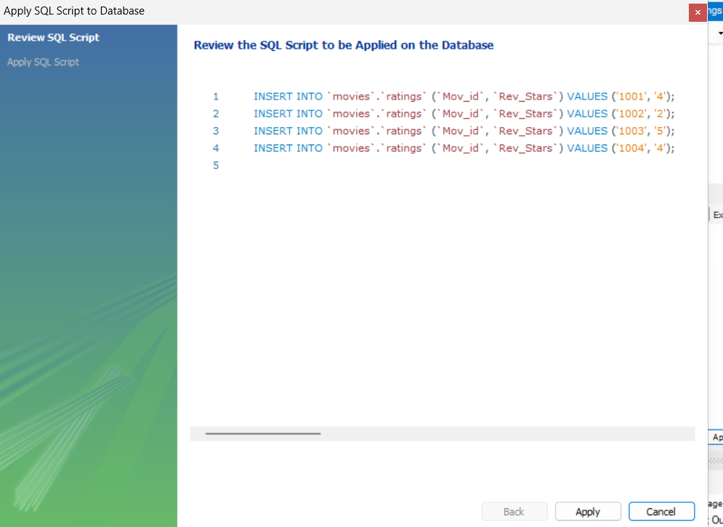

1. List the titles of all movies directed by ‘Hitchcock’.

SELECT Mov_Title

FROM movie

WHERE Dir_id = (

SELECT Dir_id

FROM director

WHERE Dir_Name = 'HITCHCOCK'

);

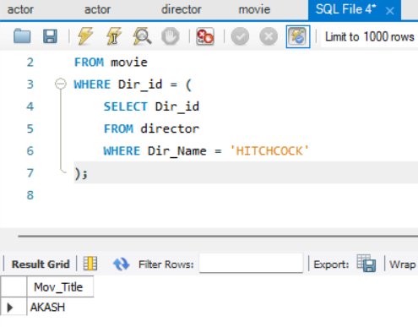

1. Find the movie names where one or more actors acted in two or more movies.

SELECT DISTINCT Mov_Title

FROM movie

WHERE Movie_id IN (

SELECT Mov_id

FROM movie_cast

WHERE Act_id IN (

SELECT Act_id

FROM movie_cast

GROUP BY Act_id

HAVING COUNT(DISTINCT Mov_id) >= 2

)

);

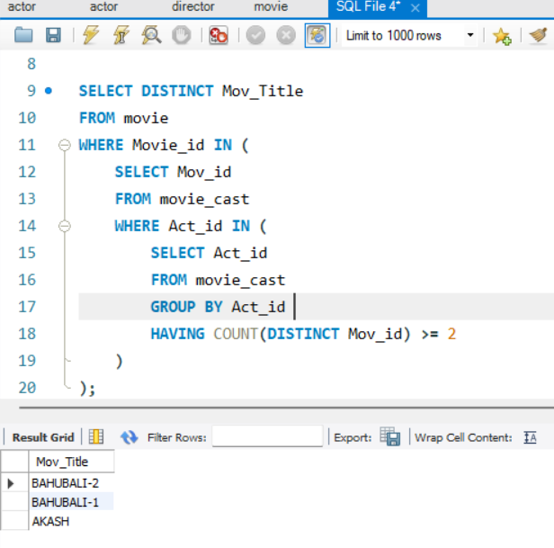

1. List all actors who acted in a movie before 2000 and also in a movie after 2015 (use JOIN operation).

SELECT DISTINCT a.Act_Name

FROM actor a

JOIN movie_cast mc1 ON a.Act_id = mc1.Act_id

JOIN movie m1 ON mc1.Mov_id = m1.Movie_id

JOIN movie_cast mc2 ON a.Act_id = mc2.Act_id

JOIN movie m2 ON mc2.Mov_id = m2.Movie_id

WHERE m1.Mov_Year < 2000 AND m2.Mov_Year > 2015;

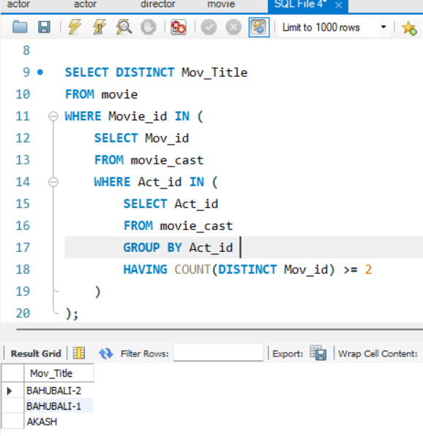

1. Find the title of movies and number of stars for each movie that has at least one rating and find the highest number of stars that movie received. Sort the result by movie title.

SELECT m.Mov_Title, MAX(r.Rev_Stars) AS Highest_Stars

FROM movie m

JOIN ratings r ON m.Movie_id = r.Mov_id

GROUP BY m.Mov_Title

ORDER BY m.Mov_Title;

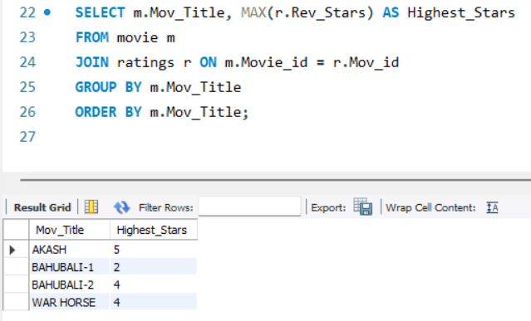

1. Update rating of all movies directed by ‘Steven Spielberg’ to 5.

UPDATE ratings

SET Rev_Stars = 5

WHERE Mov_id IN (

SELECT Movie_id

FROM movie

WHERE Dir_id = (

SELECT Dir_id

FROM director

WHERE Dir_Name = 'STEVEN SPIELBERG'

)

);

select *from ratings;

